**1. The data smoothed out after winsorized at 1 and 99 percentiles.**

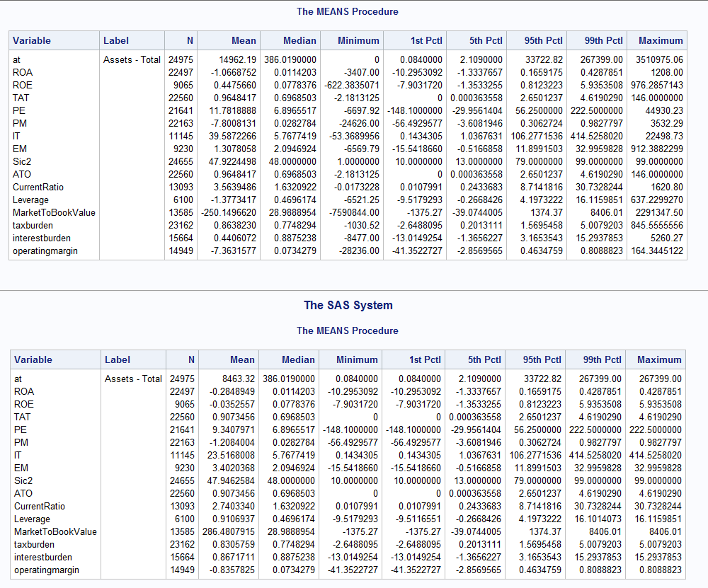

**2. There is difference in profitability among the 3 groups. Group 0 typically has negative profitability variables, indicating losses on average. Group 2 has the largest profitability variables. Profitability increases as total asset increases.**

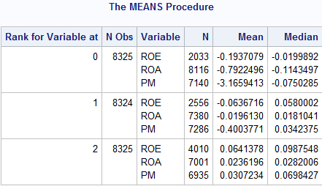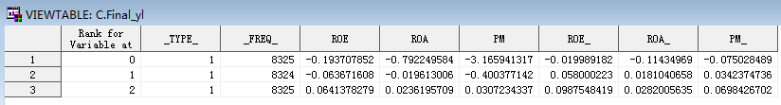3. **Plot 3 factor Du Pont analysis for the whole sample:**

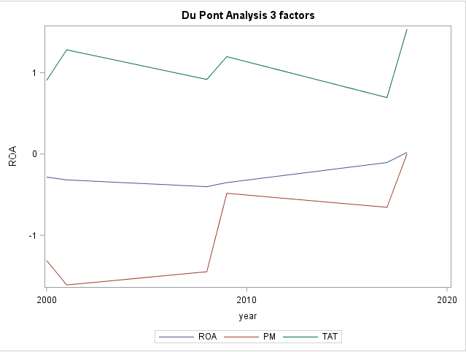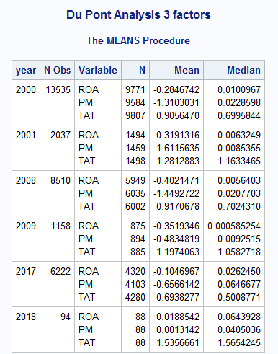

**4. Plot 3 factor Du Pont analysis for a two-digit SIC industry where sic2=42:**

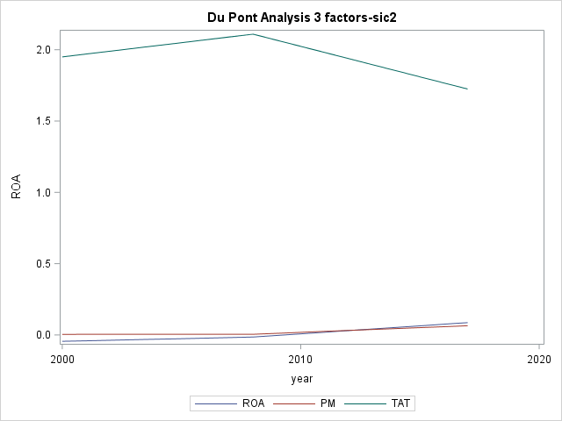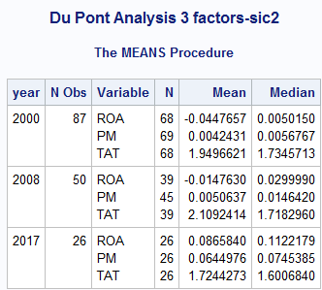

**Insights:**

* **Profit margin and return on asset for a single industry is more concentrated than the profit margin and return on asset for the whole sample, indicating that companies in the same industry have similar profit and asset structure.**
* **The whole sample typically has negative profit during the 3 years, while the industry with sic2=42 has profit around zero.**
* **This particular industry has higher total asset turnover rate and higher profit margin than the whole sample.**

**5. The natural log of firm total assets has t Value equal to 3.37, indicating that this parameter is significantly different than zero, and that it is related to the dependent variable. The probability of the natural log of firm total assets is less than 10%, indicating that this parameter is more likely different than zero. The larger the t value and the smaller the probability, the parameter is statistically significant in explaining ROE.**

**In addition, leverage, asset turnover, and return on asset are statistically significant in explaining ROE because they have probability less than 10% and relatively large absolute t values. The probabilities of market to book value and current ratio are greater than 10%, showing these parameters are less likely different than zero and less statistically significant in explaining ROE.**

